Part 1

There seem to a few cards that have 9-13 transactions of < $2. We would need to see if they are all at the same day or a different day to know if it is hacked.

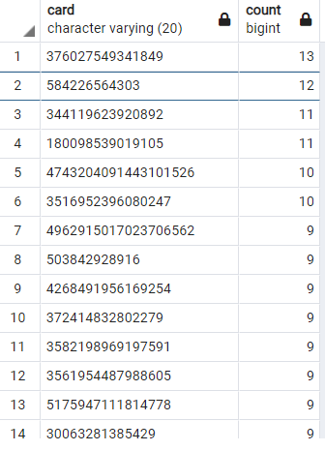

Figure : Transactions < $2

Top 100 Transactions.

Both the time frames (7am to 9am) and (< 7am and > 9am) have large transactions. However the transactions with many decimal places seem odd. Comparing 2 hrs with 22 hrs visually seems to be not very rigorous. So I cannot really make a call

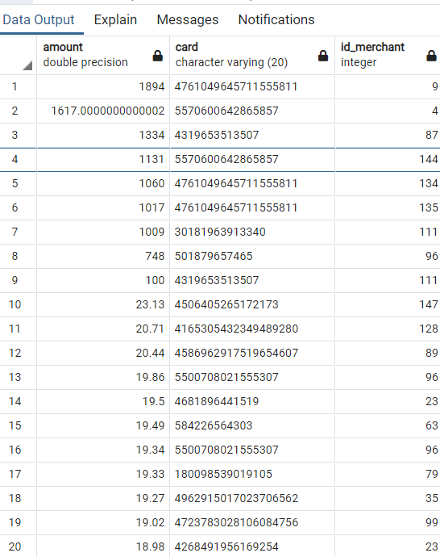

Figure Transactions between 7 and 9

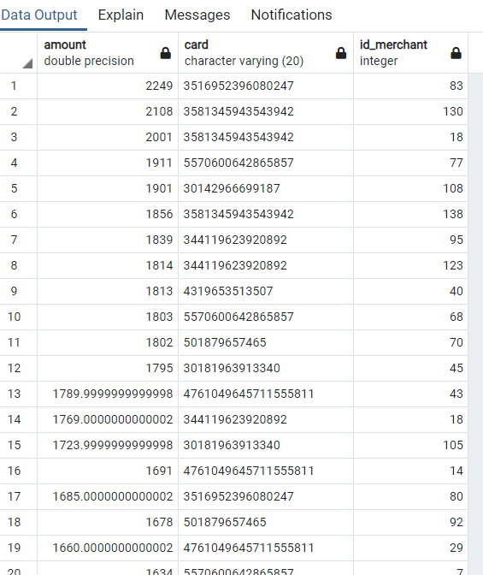

Figure Transactions before 7am or after 9am